Last Revision Date
Re-Opening the Facility Name Office and Operations
A. OBJECTIVES:
- Always provide safe and adequate water.
- Protect Staff such that business can be conducted to support Objective 1.
- Pay Bills.
- Receive payment for water sales to support Objective 2.

B. WORKING ASSUMPTIONS:
1. The old “Normal” is gone, and uncertainty exists as to “New Normal”, specifically:
a. COVID-19 is here to stay and
b. No Vaccine, or quick & accurate Test, or specific treatment is yet available.
2. In general, Safety issues can be alleviated/minimized by: Engineered Solutions, and/or Administrative Controls, and/or Protective Equipment.

C. Immediate Actions the water supply can operate in the “New Normal” culture:
1. Comply with “Workplace Health and Safety Guidance for Employees and Staff of Businesses”, April 30, 2020, attached as Item “E” on page 4, and Specifically:
- Make sure that you can maintain at least 6 feet of physical separation between yourself and others around you, including your co-workers and customers.
- Mark with signage or tape 6-foot spacing for employees and customers to maintain appropriate distance from one another.
- Provide face coverings to employees, especially when it is not possible to maintain at least 6 feet of space between you and another person.
- Provide hand washing stations with soap, clean water, and single use paper towels and encourage frequent hand washing for 20 seconds or longer.
- Provide hand sanitizer (with at least 60% alcohol) & sanitizing products for employees and customers.
- Regularly clean high-touch surfaces including doorknobs, light switches, shared equipment, toilet handles, sink faucets, and clock in/out areas.
- Employees should not work if they are sick.
2. Continue Social Distancing between Staff and the Public:
a. Continue Closed Office & Lab to Public, & entrance doors locked at all times,
- In-office meeting by pre-arranged appointment only.
- Only one Visitor at a time.
b. Continue masks/ gloves/ sanitizer use when in public areas.
c. Prior to any visitor entering Office or WTP Lab, or Staff member entering customer home or business, an adequate health history of the proposed visitor or visit site must be taken by phone first. (i.e.: Has anyone been exposed to COVID-19, on voluntary or other quarantine? Is anyone sick or have fever? Has anyone traveled out of state or country in last 2 weeks?).
- High risk visits should just be rescheduled unless dire (emergency) need.
d. To enter Customer home or business: Operators should have available masks, gloves, face shields, disposal coveralls, and “booties” shoe covers.
e. Schedule Customers’ visits late in afternoon or weekends to meet customers’ schedules, and so Operator can go home for shower/clothes change/disinfection.
f. Drive separately to field work sites and work as separately as possible, if more than 1 person needed for work outside of CTPWD buildings.
g. Continue Staff cleaning Office and Lab at end of every shift, and cleaning floors at least weekly per CDC/EPA guidelines (REF: https://www.epa.gov/pesticide-registration/list-n-disinfectants-use-against-sars-cov-)
- Remove all non essential surfaces that may be touched (decor etc) in office to make cleaning easier
- Or, weekly "ServPro" professional cleaning and sterilization ($100?)??

3. Potential Office Operational/Structural Changes:
a. Promote On-Line Credit Card payments (consider incentives)
b. Install professional appearance, permanent “Sneeze Guards” or Fabricated Plexi-Glass Shields mounted above Office Counter to separate Desk Areas from Common area. REF: https://www.menards.com/main/doors-windows-millwork/acrylic-glass-sheets/amerilux-0-220-thick-clear-acrylic-sheets/cla18x24x220/doors-windows-millwork/acrylic-glass-sheets/amerilux-0-220-thick-clear-acrylic-sheets/cla36x72x220/p-1539107082071.htm
c. Pedestal tape divider or barrier to keep Customers in designated area.
d. Move Desks / Work Stations at least 6 feet away from each other in Office.
e. Install an improved “Drop Box” through wall so Customers can deposit payments without entering building, or even touching door knobs.
f. Construct barriers/large planters/bollards outside office works spaces.

4. Potential procurement of UV-C or far-UV-C Disinfection lights (details in Section “F” below) to augment disinfection efforts in Office & Lab areas:
- In air ducts in office for continuous use – 88% Efficiency 1st pass,
- Portable lamps on timer after work in Lab and Office
- Kills bacteria and viruses on surfaces (doesn't penetrate carpet, etc)
- Demonstrated on Flu, Colds, Allergies - expected to work on Coronavirus
- UV-C can damage eyes, skin, and cause cancer, thus used only in unoccupied
areas, or in HVAC Duct works.
- Newly developed, shorter wavelength far-UVC light can't reach or damage living human cells, but can penetrate and kill the very small viruses and bacteria floating in the air or on tables and other surfaces - Availability??

5. Vaccinations every year:
- Strongly recommend all staff and Board members be inoculated for the Flu annually.
- When available, the same recommendation for Covid-19 vaccination.

D. ADDITIONAL FUTURE CONSIDERATIONS:
- If a substantial increase in cases of COVID-19 occurs increase cross training of staff and backups.
- Separate Operator Office area in Shop for Field Operations vs Plant Ops.
- Develop Flexible/Alternate shifts.
E.g., Establish a rotating schedule where one Operator works 5:00AM to 1:00PM and another works 1:00 to 9:00 p.m. Or, two Operators work Monday-Thursday 10 hr shifts and a third Operator works Friday-Saturday-Sunday 10 hour shifts.
- “Drive-Through-Window with 2-way Pass-Through Drawer” (through wall to outside) for customers and passing Work Orders out-and-back on same day. (Ref: https://www.quikserv.com/)

BACKGROUND INFORMATION

E. April 30, 2020 Stay At Home Order: http://dph.illinois.gov/sites/default/files/Stay%20at%20Home%20Order%20-%20IDPH-OAG%20Workplace%20Health%20and%20Safety%20Guidance.pdf

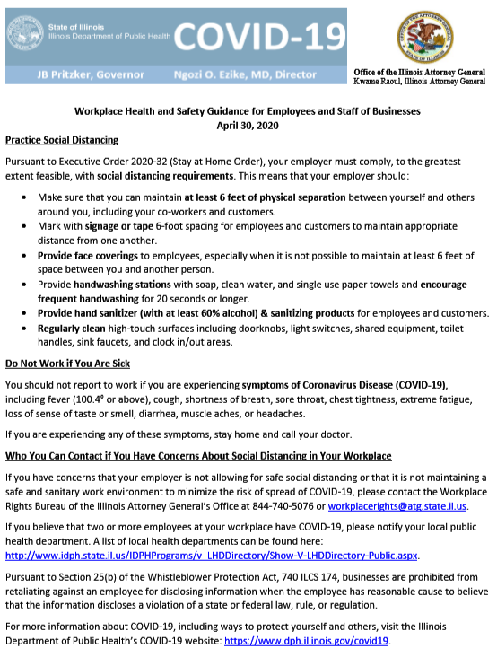
F. UV-C DISINFECTION LIGHTS:

1) EXCERPT from Phillips Lighting https://www.lighting.philips.com/main/products/special-lighting/uv-purification

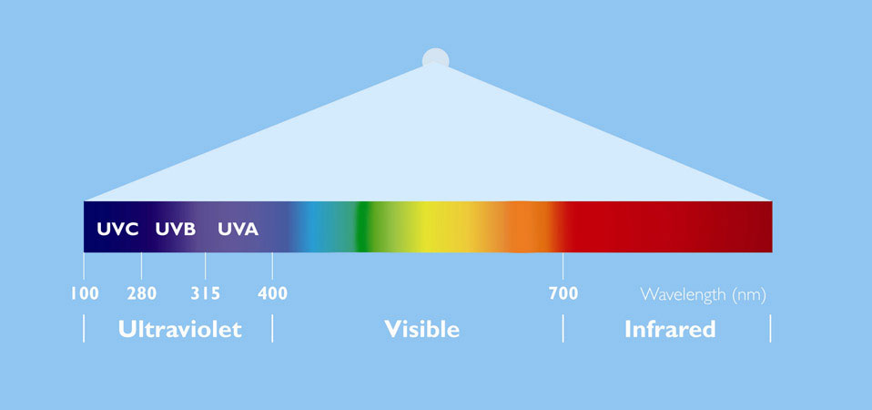

What is UV technology

Ultra-Violet (UV) light is invisible to human eyes. It can be subdivided into three categories: UVA, UVB and UVC. UV-A from 315 to 400 nm UV-B from 280 to 315 nm UV-C from 100 to 280 nm.
UVC radiation is known to break the DNA of bacteria, viruses and spores. As a result, they are rendered harmless.

UV radiation can be used for multiple purposes in water and air treatment, but is primarily employed as a disinfection process that inactivates micro-organisms without chemicals. For other applications, UV is used for the removal of organic and inorganic chemicals, including chlorine, chloramines, ozone and Total Organic Carbon (TOC) emerging contaminants.

Benefits of UVC technology

UVC radiation has been proven to be effective against waterborne pathogenic microorganisms including those responsible for cholera, hepatitis, polio, typhoid, giardia, cryptosporidium and many other bacterial, viral and parasitic diseases
UVC radiation can be used to destroy chemical contaminants such as pesticides, hormones and other pharmaceuticals in drinking water or waste water
UVC installations have low capital and operation cost
UVC technology is environmentally friendly
UVC installations are easy to operate and to maintain
UVC radiation has no harmful effect TO SURFACES when overdosed
UVC radiation works instantly and the effectiveness does not depend on the water temperature
UVC disinfection is a physical process: no substances are added to the water
UVC disinfection is complementary to Chlorine disinfection: it deactivates organisms that are resistant to Chlorine such as giardia and cryptosporidium
UVC lamps can be easily regulated to optimise treatment for variations of water quality and for changing water flows
UVC radiation will keep the surface of reservoirs clean from biofilm
The UVC disinfection effect is directly related to the UV dose (which is the product of intensity and exposure time of the micro-organisms) so it’s effectiveness can be simply measured once the system design is validated
2) Reference: https://eveescloset.com/products/38w-uv-lamp

UVC LIGHT HAS BEEN SHOWN TO INACTIVATE (AKA, ‘KILL’) VIRUSES THAT ARE NEAR-RELATIVES OF THE VIRUS: SARS-COV-1 AND MERS-COV. THEREFORE IT IS WIDELY EXPECTED TO BE EFFECTIVE AGAINST VIRUSES
There are three UV light wavelength categories: UVA, UVB and UVC. Our LAMP produces UVC, the only wavelength known to be germicidal.
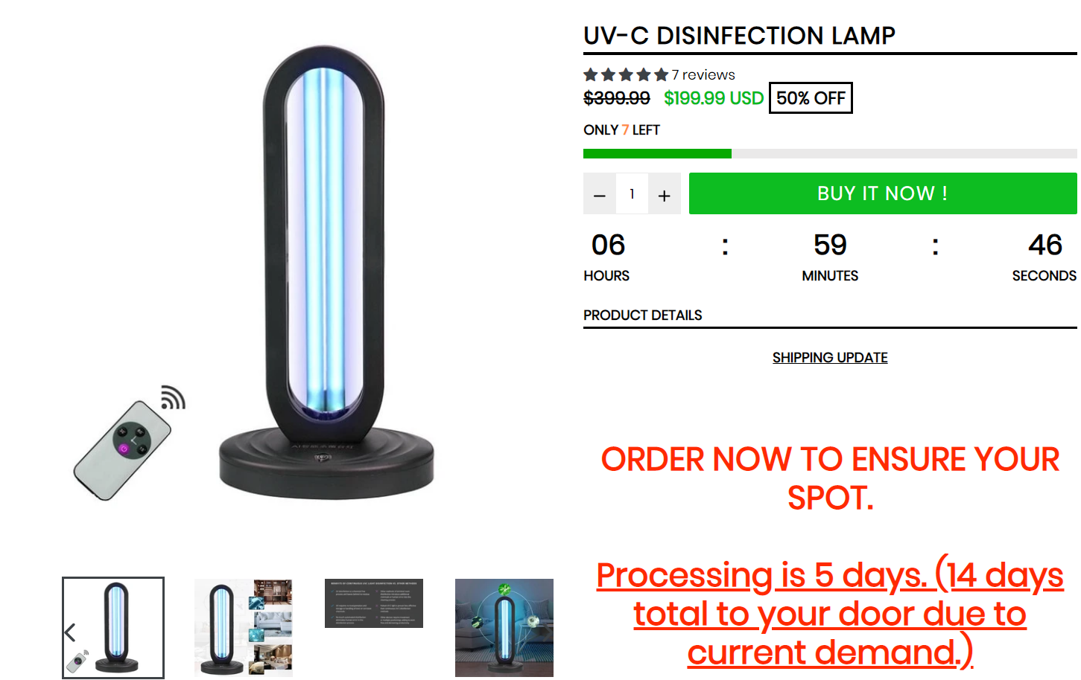
WHY OUR UV-C LAMP? The capacity is suitable for 10-25 sqm space, living room, bedroom and other household space, only 15 minutes for rapid sterilization and disinfection.
UV-C can sterilize places where ultraviolet light cannot reach.
• Ultraviolet (UV-C) light help to eliminate 99% bacteria, viruses, fungus, molds, etc on the surfaces of most household and personal items. Remove odors, bacteria, and dust motes which cause splenitis, pneumonia, asthma, and allergies.
• Portable design: space saving, to sterilize in the required area at any time.
• Simple operation easy to press ON/OFF button.
• Products used in your daily life, spoons, dishes, telephone handsets, desk, toilets, public places, automobile, etc, free from harmful bacterial pathogens. Keeping your rooms, closets and household appliances in a “Germ Free” antiseptic environment.

3) Chagona Products: https://www.chagona.com/products/uv-disinfection-lamp-38w

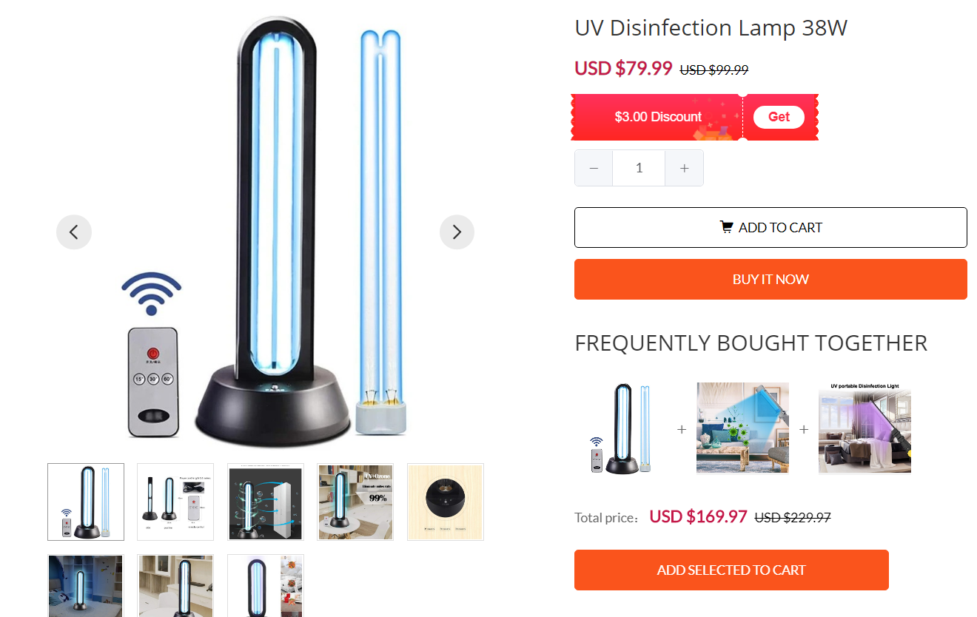

4) Far-UV-C Technology- EXCERPTED Report published April 9, 2020:
https://www.post-gazette.com/news/health/2020/04/09/Ultraviolet-technology-far-UVC-light-disinfectant-COVID-19-coronavirus/stories/202004080113

As researchers race to make effective vaccines to inoculate against COVID-19, development of new, better and faster disinfectant devices to slow its spread is also a high priority.
One of the brightest areas of that scientific research involves a spectrum of ultraviolet light — called “far-UVC light” — that kills the virus but doesn’t harm humans.
Use of far-UVC lamps, which provide little if any actual light, could eventually allow treatment of air and surfaces in many occupied indoor spaces, including hospital rooms. That would greatly reduce the viral exposure for hospital patients and medical personnel, and speed sterilization of the rooms and medical equipment, said David Brenner, a professor of radiation biophysics and director of the Center for Radiological Research at Columbia University in New York City.
“What we have developed is a particular UV wavelength region, around 222 nano-meters, which is as effective as conventional germicidal UV at killing viruses and bacteria but is also safe for human exposure,” Mr. Brenner said in an email response to questions. “So it can be used in occupied public spaces.”
Conventional, longer wavelength ultraviolet light has been used very effectively for more than a century to decontaminate air, water and surfaces in unoccupied indoor spaces. But it can cause cancer and cataracts in humans exposed to it.
The shorter wavelength far-UVC light can't reach or damage living human cells, but can penetrate and kill the very small viruses and bacteria floating in the air or on tables and other surfaces.
Mr. Brenner said overhead far-UVC lights “could be used in any indoor location where people congregate,” including in hospitals, doctors’ offices, schools, airports, airplanes, trains, buses and other public spaces, and could help block the spread of the coronavirus.
Mr. Brenner said his team of researchers has been working for five years on development of far UVC lighting with a focus on its safety and effectiveness. Similar development is taking place in Japan, he said.
A 2018 study headed by Mr. Brenner and published in the peer-reviewed, on-line journal Scientific Reports, found that continuous low doses of far-UVC light can kill airborne viruses without harming human tissues, and inhibit seasonal influenza epidemics, as well as influenza pandemics.
The new far UVC lamps, in production by Ushio America Inc. and Eden Park Illumination, are not yet approved for medical uses but could be soon.
“The two roadblocks are ramping up to high capacity production and (Food and Drug Administration) approval,” Mr. Brenner said. “A couple of weeks ago my best guess for both might be nine months but we are now trying to go faster than that.
Late last month the FDA issued an advisory that clears the way for use of sterilizer and disinfection devices, including the far-UVC lamps, in hospitals and other public health settings during the unique coronavirus pandemic and prior to formal FDA approval.
Dr. David Atcheson, a retired oral and maxillofacial surgeon in Pittsburgh, said it’s past time to accelerate the UVC approval process and utilize the technology.
“We need someone to push this technology along, someone to shine a light on UV light,” Dr. Atcheson said. “We need to get these lights out there and in use sooner than nine months from now.”
Ryan Olsen, eastern regional sales manager at Ushio America, a subsidiary of Tokyo, Japan-based Ushio Inc., said the far-UVC lamps have been in limited production since 2018 but the COVID-19 pandemic has heightened interest from medical facilities. He said the lamps, which Ushio sells as components to production companies and not to the public, use a special filter to ensure no harmful wavelengths are emitted.
“We are ramping up production and working quickly now because we see the benefits of this type of lighting,” Mr. Olsen said. “While (far-UVC) light does significantly reduce the amount of influenza and other viruses and pathogens on surfaces and in air, these issues will still be a fact of life ... just hopefully not in the severity we see them today.”
Cy Herring, Eden Park’s president, said the Champaign, Ill., company has been working with Mr. Brenner on a National Institutes of Health contract focusing on UV lights, and has been producing a small number of the far-UVC lamps for industrial applications since 2018.
“Now there’s a big interest from the healthcare industry that’s vastly larger than it was a couple of months ago, and that’s been reflected in our orders,” Mr. Herring said,
The lights are not cheap, but expanded production and sales could reduce their prices. A thin, two-inch square light, smaller than a drink coaster, costs about $500; a four-inch light a little more than $1,000, said Mr. Herring, adding that demand is strong and the company is looking to expand and hire more workers.
“We feel like we have a product that can help and prevent the spread of the virus from person to person,” he said. “We’re trying to figure out how to implement distribution. We’re trying to do the best we can in a time of crisis.”
Juliet Ferrelli, director of infection prevention at Allegheny Health Network’s eight hospitals, said the healthcare system is aware of the far-UVC technology and recognizes its potential to complement existing use of ultraviolet decontamination systems in air handling units at all of its hospitals. UPMC also uses UV light treatments in its hospital bulk air handling systems.
“We’ve explored the use of far-UVC light in ERs (emergency rooms) and operating rooms and are looking into the technology, especially for the new hospital we are building in Wexford,” Ms. Ferrelli said.
She said that while UV light is a well proven disinfection method, retrofitting all the rooms in an existing hospital would be quite expensive. AHN also uses mobile UV light robots, at its Allegheny General, Forbes and West Penn hospitals, but those robots can only be used in unoccupied rooms.“We are looking at use of the (far-UVC lighting) in other health care settings and evaluating if it makes sense in every hospital, in every room. And, given that we already use UV in our air handling, do we need both?“But as passive equipment for infection prevention, I definitely see its use as growing in the healthcare field.”
Don Hopey: dhopey@post-gazette.com or 412-263-1983. Twitter: @donhopey.

5) Far-UVC EXCERPT from: https://www.biorxiv.org/content/10.1101/240408v1.full.pdf
Abstract, posted December 28, 2017
Airborne-mediated microbial diseases such as influenza and tuberculosis represent major public health challenges. A direct approach to prevent airborne transmission is inactivation of airborne pathogens, and the airborne antimicrobial potential of UVC ultraviolet light has long been established; however, its widespread use in public settings is limited because conventional UVC light sources are both carcinogenic and cataractogenic.
By contrast, we have previously shown that far-UVC light (207- 17 222 nm) efficiently kills bacteria without harm to exposed mammalian skin. This is because, due to its strong absorbance in biological materials, far-UVC light cannot penetrate even the outer (non living) layers of human skin or eye; however, because bacteria and viruses are of micrometer or smaller 20 dimensions, far-UVC can penetrate and inactivate them. We show for the first time that far-UVC efficiently kills airborne aerosolized viruses, a very low dose of 2 mJ/cm2 21 of 222-nm light inactivating 22 >95% of aerosolized H1N1 influenza virus. Continuous very low dose-rate far-UVC light in indoor public locations is a promising, safe and inexpensive tool to reduce the spread of airborne-mediated microbial diseases.

G. ILCS Credit Card Fees Legistration, November 11, 2019:

1) Secretary of State Policy: 
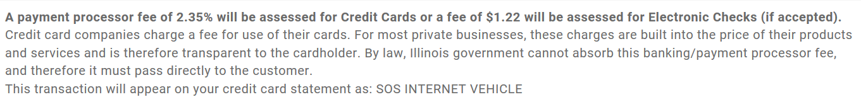

2) Illinois Government Legislation EXCERPT:
http://www.ilga.gov/legislation/ilcs/fulltext.asp?DocName=005003450K25

50 ILCS 345/25)
Sec. 25. Payment of fees by cardholders.
(a) The governing body of a local governmental entity authorizing acceptance of payment by credit card may, but is not required to, impose a convenience fee or surcharge upon a cardholder making payment by credit card in an amount to wholly or partially offset, but in no event exceed, the amount of any discount or processing fee incurred by the local governmental entity. This convenience fee or surcharge may be applied only when allowed under the operating rules and regulations of the credit card involved. When a cardholder elects to make a payment by credit card to a local governmental entity and a convenience fee or surcharge is imposed, the payment of the convenience fee or surcharge shall be deemed voluntary by the person and shall not be refundable.
(b) No fee, or accumulation of fees, that exceeds the lesser of $20 or 5% of the principal amount charged may be imposed in connection with the issuance of any license, sticker, or permit, or with respect to any other similar transaction. No fee, or accumulation of fees, that exceeds the lesser of $5 or 5% of the transaction involved may be imposed in connection with the payment of any fine. No fee, or accumulation of fees, in excess of the lesser of $40 or 3% of the principal amount charged may be imposed in connection with the payment of any real estate or other tax.
(c) Notwithstanding the provisions of subsection (b), a minimum fee of $1 may be imposed with respect to any transaction.
Notwithstanding the provisions of subsection (b), a fee in excess of the limits in subsection (b) may be imposed by a local governmental entity on a transaction if (i) the fee imposed by the local governmental entity is no greater than a fee charged by the financial institution or service provider accepting and processing credit card payments on behalf of the local governmental entity; (ii) the financial institution or service provider accepting and processing the credit card payments was selected by competitive bid and, when applicable, in accordance with the provisions of the Illinois Procurement Code; and (iii) the local governmental entity fully discloses the amount of the fee to the cardholder.
(Source: P.A. 92-114, eff. 1-1-02.)

